**High-Level Steps for building the CRM 2.0**

Contents

Create an Elastic Beanstalk environment that utilizes RDS 1

Build a PHP Laravel website and upload it to the Elastic Beanstalk environment 1

Create a table in the RDS database 3

Build classes in the web app that can access the table and subscribe or unsubscribe consumers 4

Create a Lambda function that can send welcome emails via SES to consumers who have subscribed, and update the RDS database. 4

Schedule the Lambda function with EventBridge 5

# Create an Elastic Beanstalk environment that utilizes RDS

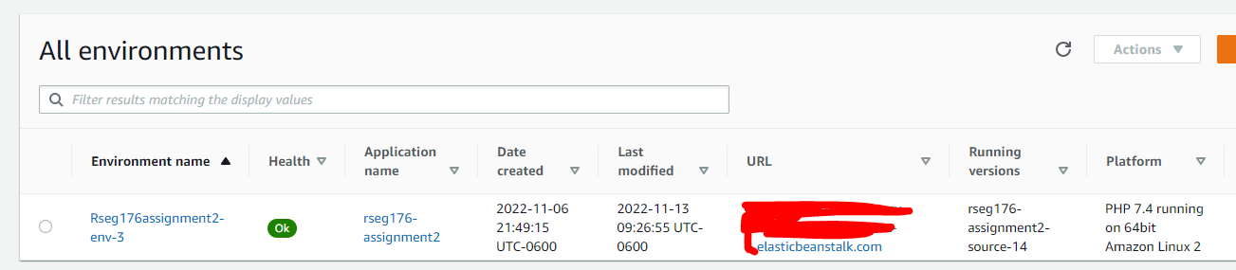

# Build a PHP Laravel website and upload it to the Elastic Beanstalk environment

This tutorial was very helpful with this:

https://docs.aws.amazon.com/elasticbeanstalk/latest/dg/php-laravel-tutorial.html

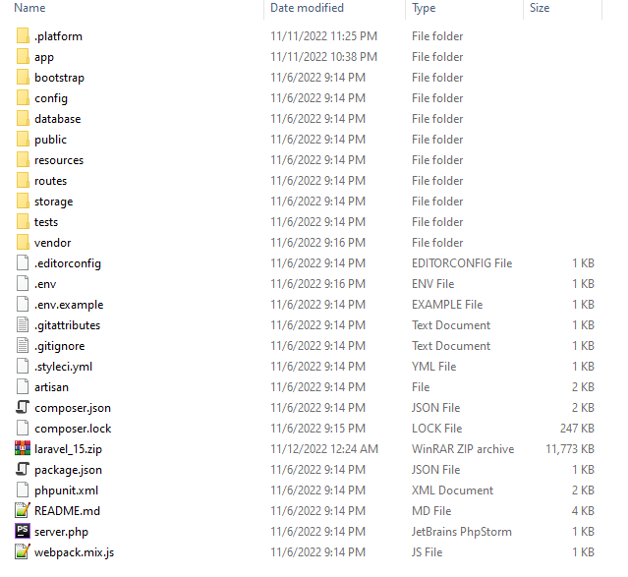

# Create a table in the RDS database

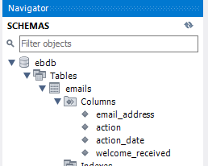

# Build classes in the web app that can access the table and subscribe or unsubscribe consumers

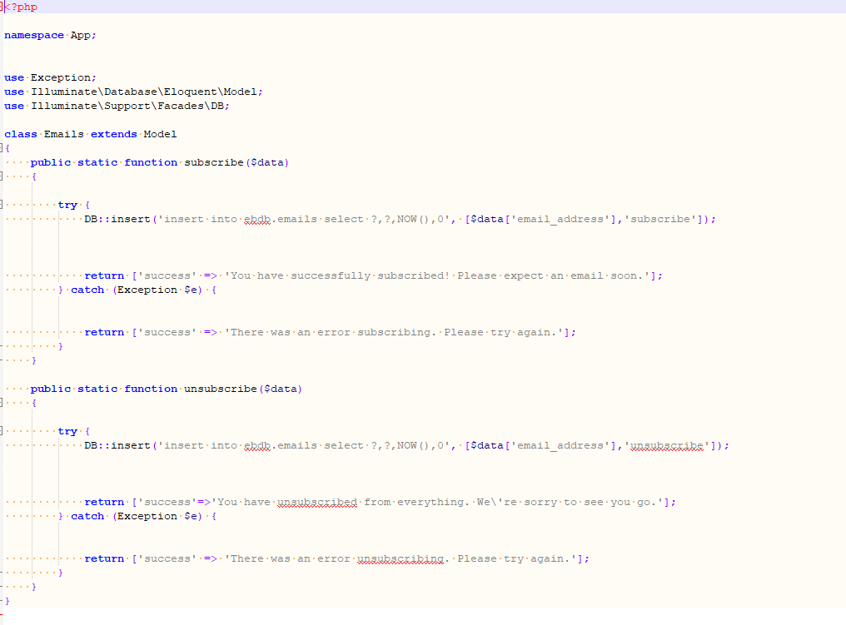

# Create a Lambda function that can send welcome emails via SES to consumers who have subscribed, and update the RDS database.

This was a tricky step. RDS sits in a VPC and SES’s APIs are public. This requires creating private and public subnets in the VPC that allow the Lambda function to access RDS and SES. This tutorial was very helpful:

https://aws.amazon.com/premiumsupport/knowledge-center/internet-access-lambda-function/

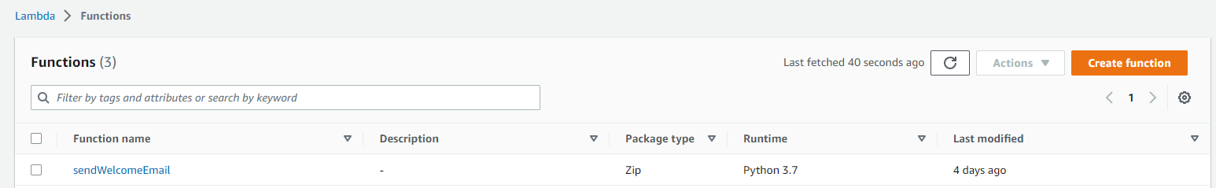

# Schedule the Lambda function with EventBridge

